Zomato Restaurant Expansion

**Answers for objective questions.**

**1. What is the total no. of tables present in the data?**

Ans: There are 2 tables present in the data :  
1) **Raw data sheet** which contains all the information about the various restaurants in various countries .  
2) **Country description** that contains the country code for the various countries which helped us to retrieve the country on the basis of the country code provided.

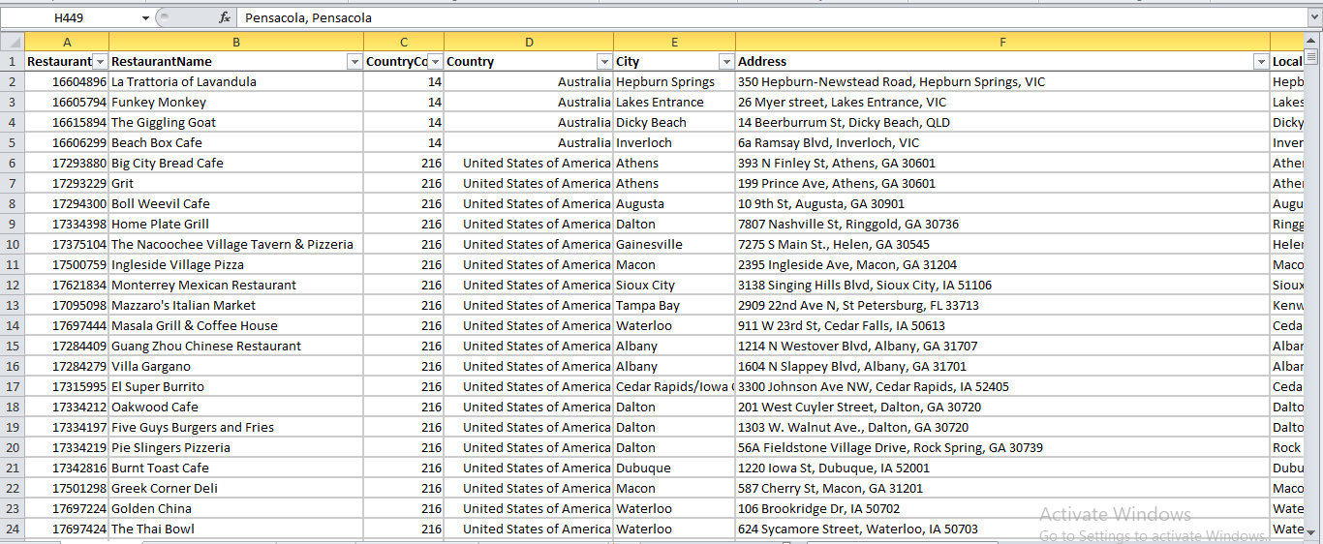  
Fig 1.1 Raw data sheet

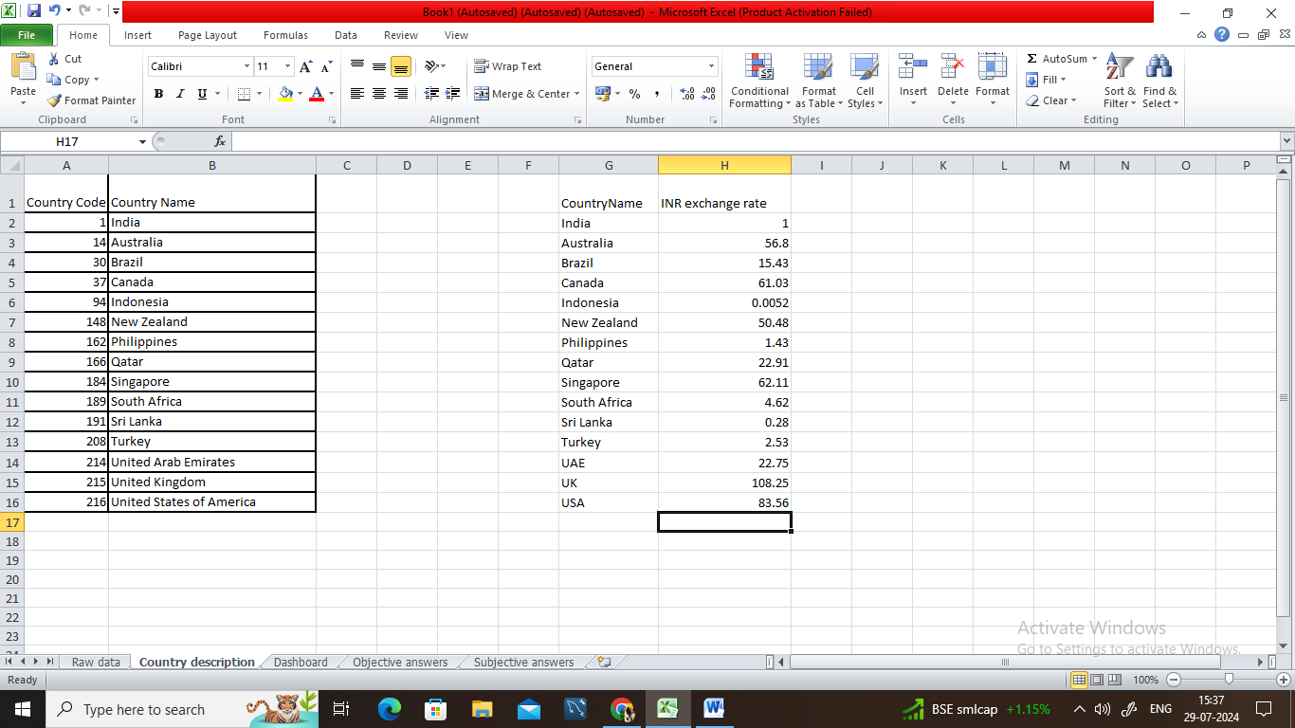  
Fig 1.2 Country Description

**2. What is the total no. of attributes present in the data?**

Ans: In total there are 21 attributes present in the data.

* **Restaurant ID:** Unique identifier for each restaurant.
* **Restaurant Name:** The name of the restaurant.
* **CountryCode:** Country code of the location where the restaurant is situated.
* **Country:** Country name of the location where restaurant is opened.
* **City:** The city where the restaurant is located.
* **Address:** The specific address of the restaurant.
* **Locality:** The locality or neighborhood where the restaurant is situated.
* **Locality Verbose:** Detailed information about the locality.
* **Longitude:** The geographical longitude coordinate of the restaurant.
* **Latitude:** The geographical latitude coordinate of the restaurant.
* **Cuisines:** The type of cuisine offered by the restaurant.
* **Currency:** The currency used for transactions in the restaurant.
* **Has_Table_booking:** Indicates whether the restaurant has a table booking option (Yes/No).
* **Has_Online_delivery:** Indicates whether the restaurant offers online delivery (Yes/No).
* **Is_delivering_now:** Indicates whether the restaurant is currently delivering (Yes/No).
* **Switch_to_order_menu:** Indicates whether users can switch to the order menu (Yes/No).
* **Price_range:** A numeric value indicating the price range category of the restaurant.
* **Votes:** The number of votes or ratings/(feedback) received by the restaurant.
* **Average_Cost_for_two:** The average cost for two people dining at the restaurant.
* **Rating:** The overall rating of the restaurant is based on user reviews.
* **Datekey_opening:** The date when the restaurant was opened.

**3. How many categorical columns are there in the data? [Search about categorical and continuous data, and try to answer this question]**

Ans**:**  No. of categorical column = 14(Country code, Country, City, Cuisines, Currency, Table booking, Online delivery, Is delivering now, Switch to order menu, Price Range, Votes, average cost for two, Rating, Opening date)

**4. The data consists of some inconsistent and missing values so ensure that the data used for further analysis is cleaned.**

* There were missing values in the cuisines column so removed those rows .
* There were some rows containing ‘ 0’ as a value for average cost for two since it cannot be zero so removed those rows and also in the votes column removed the rows that has zero votes in order to clean it.
* Inconsistent data that was the date so corrected it in a right format by replacing the underscore(_) by hyphen(-)
* Removed duplicates using the Remove Duplicate Feature.

**5. Using the LookUp functions, fill up the countries in the original data using the country code.**

Ans: Done in the original data by using the Vlookup formula in column D using the data given in the country description.

=VLOOKUP(C9530,'Sheet 2'!$A$1:$B$16,2,0)



Fig1.3 Sheet with country name

**6. Create a table to represent the number of restaurants opened in each country.**

Ans: Numbers of restaurants opened in each country are listed below:

|  |  |
| --- | --- |
| **Country** | **Count of Restaurant** |
| Australia | 24 |
| Brazil | 59 |
| Canada | 4 |
| India | 7550 |
| Indonesia | 21 |
| New Zealand | 40 |
| Philippines | 22 |
| Qatar | 20 |
| Singapore | 20 |
| South Africa | 60 |
| Sri Lanka | 20 |
| Turkey | 34 |
| United Arab Emirates | 60 |
| United Kingdom | 80 |
| United States of America | 419 |
| **Grand Total** | **8433** |

From this we can conclude that 90% of the restaurants are opened in India and after India USA is on second position however its just 1.05% of India

**7. Also, the management wants to look at the number of restaurants opened each year, so provide them with something here.**

Ans: Created a pivot table and grouped it per year to count the number of restaurants opened per year .

|  |  |
| --- | --- |
| **Year** | **Count of Restaurant** |
| 2010 | 942 |
| 2011 | 979 |
| 2012 | 908 |
| 2013 | 944 |
| 2014 | 917 |
| 2015 | 902 |
| 2016 | 924 |
| 2017 | 945 |
| 2018 | 972 |
| **Grand Total** | **8433** |

Here we can see in the last four years the number of restaurants opened per year has increased year by year. And the least number of restaurants were opened in 2015 and in 2011 the no. of restaurants opened was the highest.

**8. What is the total number of restaurants in India in the price range of 4?**

Ans: For this we have used a pivot table where we have applied the filter on price range as 4. Taken countries in the rows and count of price range as values.

|  |  |
| --- | --- |
| **Country** | **Count of Price_range 4** |
| Australia | 1 |
| Brazil | 35 |
| Canada | 1 |
| India | 383 |
| New Zealand | 16 |
| Philippines | 9 |

In the above we can see that in India there are **383 restaurants** which are in the price range of 4

**9. What is the average number of voters for the restaurants in each country according to the data?**

**Ans:** We can calculate the average number of voters by calculating the average number of votes as 1 voter can have 1 vote only and we have done this by creating a pivot table.

And values has been rounded off in the whole numbers to have a clear understanding.

|  |  |  |  |  |  |  |  |  |  |  |  |  |  |  |  |  |  |  |  |  |  |  |  |  |  |  |  |  |  |  |  |  |  |  |  |
| --- | --- | --- | --- | --- | --- | --- | --- | --- | --- | --- | --- | --- | --- | --- | --- | --- | --- | --- | --- | --- | --- | --- | --- | --- | --- | --- | --- | --- | --- | --- | --- | --- | --- | --- | --- |
| |  |  | | --- | --- | | **Country** | **Average of Votes** | | Australia | 111 | | Brazil | 20 | | Canada | 103 | | India | 157 | | Indonesia | 772 | | New Zealand | 243 | | Philippines | 407 | | Qatar | 164 | | Singapore | 32 | | South Africa | 315 | | Sri Lanka | 146 | | Turkey | 431 | | United Arab Emirates | 494 | | United Kingdom | 205 | | United States of America | 436 | | **Grand Total** | **177** | |  |

From the above table we can conclude that Indonesia has got the highest number of voters followed by UAE and USA

On the the other hand has the least amount of voters.

**10. Calculate the average rating for all the restaurants that have price_range < 4 and provide online delivery. Use only the “IF” function, Logical Operators, and Aggregation functions to solve this problem. [Note: Don’t use Conditional aggregation in this question.]**

Ans: Used IF , AND operator to the restaurants that have price_range < 4 and provide online delivery.

=IF(AND(R2<4,O2="Yes"),V2," ")  
where R2 is a price range and O2 is has_online_delivery and V2 is rating.

From the above formula we fetched the rating of only those restaurants who has price range less than 4 and provide online delivery. Then we found the average of all those rating with the help of below formula:

=AVERAGE($Z$2:$Z$8434)

where Z is the new column where the values we have calculated with the help of above formula are stored.

The average rating for all the restaurants that have price_range < 4 and provide online delivery is 3.29

**11. Using Conditional formatting highlight the rows of restaurants that are located in the countries or cities that you’ve suggested to the management for opening new restaurants.**

Ans: Created a different formula for different country

=$D1=”Qatar” to apply the formatting in the row where there is the restaurant in Qatar and so on.

=$D1=”Singapore” and =$D1=”Sri Lanka” and =$D1=”Canada”

**12. Create a new customized price column that consists of the abbreviation/symbol of the currency along with the Average_cost_for_two value. [Use string operations to do this task]**

Ans: Done in original data. First extracted currency symbol from currency and then concatenated the currency symbol column with average cost for two.

For extraction we used text to column and for concatenating used   
=M9530&""&T9530 where M:M is currency symbol and T:T is average cost for two

**13. How can you create an array formula in Excel or Google Sheets to count the number of restaurants listed that do not offer online delivery, are in the lowest price range, and have an average cost for two people less than or equal to 250 Indian Rupees?**

Ans: **How to create Array formula** : Firstly write the required function as per the question and then press **Ctrl+Shift+Enter**

First we will convert the average cost for two in INR for all restaurants. For this we will use VLOOKUP()

**=T2*VLOOKUP (D2,'Country description'!$G$1:$H$16,2,FALSE)**

Then we can use SumProduct( ) inside an array .The formula used is as follows:

**=SUMPRODUCT((O:O="No")*(R:R=1)*(Y:Y<=250))**

Where O column refers to online delivery R column refers to the price range and Y column refers to the Converted average cost in INR for all the restaurants.

So, we got the result that there are **1210** restaurants listed that do not offer online delivery, are in the lowest price range less than or equal to 1, and have an average cost for two people less than or equal to 250 Indian Rupees

|  |  |
| --- | --- |
|  |  |

**Answers to Subjective Questions:**

**1. Suggest a few countries where the team can open newer restaurants with lesser competition. Which visualization/technique will you use here to justify the suggestions?**

Ans: Where there are less number of restaurants we can go for those countries for restaurant expansion as the market saturation is less we can occupy a greater market and greater shares can be taken. And also we have considered the average of ratings.

For this we have created a pivot table to get an idea of the number of restaurants in each country and also taken the average ratings in values and from that we can figure out that which particular country has less market saturation.

|  |  |  |
| --- | --- | --- |
| **Country** | **Count of Restaurant** | **Average of Rating** |
| Australia | 24 | 3.7 |
| Brazil | 59 | 3.9 |
| Canada | 4 | 3.6 |
| India | 7550 | 3.0 |
| Indonesia | 21 | 4.3 |
| New Zealand | 40 | 4.3 |
| Philippines | 22 | 4.5 |
| Qatar | 20 | 4.1 |
| Singapore | 20 | 3.6 |
| South Africa | 60 | 4.2 |
| Sri Lanka | 20 | 3.9 |
| Turkey | 34 | 4.3 |
| United Arab Emirates | 60 | 4.2 |
| United Kingdom | 80 | 4.1 |
| United States of America | 419 | 4.0 |
| **Grand Total** | **8433** | **3.1** |

**Suggestion:**

* We can see that in Canada , Qatar, Singapore and Sri Lanka the saturation of restaurant is very less and also the ratings in these countries is pretty good and therefore we can suggest to open a new restaurants in these countries as we can develop a good market in these countries.
* And I highly recommend not to go for the country like India as the market saturation there is very high so to open up the restaurant and to develop a market and customer for it the cost for all these will be too high.

**2. Come up with the names of States and cities in the suggested countries suitable for opening restaurants.**

Ans: For this we have created the pivot table where we have taken the restaurant count and average cost for two people as values for the Country wise cities suggested for restaurant expansion. And average cost for two here is converted in rupees for better understanding and for the sake of simplicity.

|  |  |  |
| --- | --- | --- |
| **Country wise city** | **Count of Restaurant** | **Sum of Average cost converted to INR** |
| **Canada** | **0** | **1526** |
| Chatham-Kent | 1 | 1526 |
| Consort | 1 | 1526 |
| Vineland Station | 1 | 4272 |
| Yorkton | 1 | 1526 |
| **Qatar** | **0** | **1146** |
| Doha | 20 | 102522 |
| **Singapore** | **0** | **1242** |
| Singapore | 20 | 193473 |
| **Sri Lanka** | **0** | **280** |
| Colombo | 20 | 13300 |
| **Grand Total** | **64** | **318144** |

**Conclusion:**

* Here we can see that the number of restaurants in Canada for all the cities are same but the average cost for two is greater in Vineland Station so in Canada Vineland Station is best fit and whereas in Qatar and Sri Lanka the cities like Doha and Colombo are respectively best fit for restaurant expansion.
* Singapore is itself a city state and it fulfil our requirements and is best fit.

**3. According to the countries you suggested, what is the current quality regarding ratings for restaurants that are open there?**

Ans: Average rating in the countries suggested is greater than 3 so as per the ratings we can go for opening newer restaurants.

**Conclusion:**

* In the above chart we can see that on a scale of 5 the ratings in the suggested countries vary from 3.6 to 4.1 that suggest whatsoever the restaurants are there have a good rating and therefore we can go on opening for restaurants in those countries.
* Qatar has the highest rating of 4.1 followed by Sri Lanka with a rating of 3.9 .
* Canada and Singapore has the lowest rating in the suggested countries i.e., both have 3.6 of average rating.

**4. Also, what is the current expenditure on food in the suggested countries, so we can keep our financial expenditure in control?**

Ans: For this we have created the pivot table and prepared a chart which shows the expenditure in the suggested countries.

**Conclusion:**

* The above chart shows the current expenditure on food in the suggested countries .
* We observe that average cost for two is relatively high in all the countries where Singapore leads by Rs. 9674 followed by Qatar and Canada.
* We also observe that Sri Lanka has lowest average cost for two among all the suggested countries.

1. **Come up with the names of restaurants from the recommended states that are our biggest competitors and also those that are rated in the lower brackets, i.e. 1-2 or 2-3.**

Ans: As mentioned that 1- 3 is the lower brackets of rating so we should aim for 3.1 to 3.5 rating for our newer restaurants in the suggested cities.

For this we have created a pivot tables which shows the rating of 3.1 to 3.5 and we will consider these restaurants as our biggest competitors.

|  |  |
| --- | --- |
| **Restaurants name** | **Average of Rating** |
| **Colombo** | **3.5** |
| Chinese Dragon Cafe | 3.4 |
| Malay Restaurant | 3.5 |
| **Doha** | **3.4** |
| 7st by Mumbai Spices | 3.4 |
| Indian Coffee House | 3.4 |
| **Singapore** | **3.2** |
| Artichoke Cafe | 3.2 |
| Boufe Boutique Cafe | 3.2 |
| I Am | 3.2 |
| Potato Head Folk | 3.1 |
| Sky On 57 | 3.4 |
| Super Loco | 3.2 |
| The Lokal | 3.1 |
| The Refinery Singapore | 3.2 |
| **Grand Total** | **3.3** |

Now coming to the restaurants that are rated in the lower brackets (1-3). For this also we have created table in which we have applied filter to fetch the ratings for lower brackets(1-3).

|  |  |
| --- | --- |
| **Country wise restaurant names** | **Average of Rating** |
| **Colombo** | **2.5** |
| Elite Indian Restaurant | 2.4 |
| Queen's Cafe | 2.5 |
| **Singapore** | **3.0** |
| Makansutra Gluttons Bay | 3.0 |
| **Grand Total** | **2.6** |

**Conclusion:** We see that out of the cities suggested Vineland station is the only city that do not have any restaurants with the rating we are considering for newer restaurants.

Also we see that in Colombo 2 restaurants fall in mid rating and in the lower rating brackets also there are only 2 restaurants.

We observe that in Singapore most of the restaurants fall in mid rating brackets while in lower rating also there is 1 restaurant.

Also, we see that out of the suggested cities Colombo has 2 and Singapore has only 1 restaurant that fall in lower rating brackets all the other suggested cities has a good rating.

**6**. **Which cuisines should we focus on in the newer restaurants to get better feedback? Does the choice of cuisines affect the restaurant ratings?**

Ans:

|  |  |
| --- | --- |
| **Cuisines as per city** | **Average of Rating** |
| **Colombo** | **4.2** |
| American, Fast Food, Steak, Beverages | 4.2 |
| American, Steak | 4.0 |
| Cafe, Sri Lankan, Continental, American | 4.0 |
| Continental, American | 4.1 |
| Continental, American, Seafood | 4.2 |
| Desserts, Bakery | 4.2 |
| Desserts, Ice Cream | 4.1 |
| Fast Food | 4.1 |
| Juices, Desserts | 4.5 |
| Middle Eastern, Arabian | 4.2 |
| Seafood | 4.9 |
| Seafood, Italian | 4.0 |
| Sri Lankan | 4.0 |
| **Doha** | **4.4** |
| Chinese | 4.9 |
| Indian | 4.5 |
| International | 4.4 |
| Italian | 4.5 |
| Kerala, Indian, Chinese, Bakery | 4.0 |
| Pakistani | 4.2 |
| Seafood, American | 4.0 |
| Steak, American | 4.0 |
| Thai | 4.3 |
| **Singapore** | **4.1** |
| American, Steak | 4.0 |
| Bakery | 4.2 |
| Italian | 4.1 |
| **Vineland Station** | **4.3** |
| Italian, Mediterranean, Pizza | 4.3 |
| **Grand Total** | **4.3** |

**Conclusion:**

* Here we can see that in the suggested cities the restaurants in Colombo the cuisines like Seafood, Juices and desserts are highly rated.
* In restaurants located in Doha has good ratings for cuisines like Chinese, Indian, Italian and International.
* For Singapore the highly rated cuisines is bakery.
* For Vineland station where there is only 1 restaurant the highly rated cuisine is Italian, Mediterranean, Pizza

**7. According to our current data, should we go for online delivery and table**

**booking? Does that affect the customer’s ratings?**

Ans: for this we have created a pivot table where we are counting the online delivery and table booking

|  |  |  |
| --- | --- | --- |
| **Country wise city** | **Count of Has_Table_booking** | **Average of Rating** |
| **No** | **63** | **3.8** |
| Canada | 4 | 3.6 |
| Qatar | 19 | 4.0 |
| Singapore | 20 | 3.6 |
| Sri Lanka | 20 | 3.9 |
| **Yes** | **1** | **4.7** |
| Qatar | 1 | 4.7 |

|  |  |  |
| --- | --- | --- |
| **Country wise city** | **Count of Has_Online_delivery** | **Average of Rating** |
| **No** | **64** | **3.8** |
| Canada | 4 | 3.6 |
| Qatar | 20 | 4.1 |
| Singapore | 20 | 3.6 |
| Sri Lanka | 20 | 3.9 |

**Conclusion:**

* We see that in Qatar there is Only 1 restaurant that offers for table booking none other suggested cities has any restaurants that is offering for table booking.
* If we talk about online delivery there is not even a single restaurant that offers for online delivery.
* It shows that table booking or online delivery does not affect customer’s rating as we can see in the above table that the following cities do not offer for online delivery or the table booking still their ratings are 3+
* In conclusion to this if we go for table booking and online delivery in the suggested countries and cities it will surely attract the customers as we will be the only restaurants that offers for online delivery. And now in today’s era when everything is online so I think that if we go for online delivery it will proof to be a good strategy.

1. **Should the team keep the rate of cuisines higher? Will that affect the feedback? According to our data are the rates of cuisines and ratings, correlated?**

Here in the above chart we can see the rates of cuisines on the Y-axis and the ratings on X-axis. We have created scatter chart for the same.

**Conclusion**: We can see that the chart shows that there is a positive correlation between the ratings and the average cost.

We can see that the restaurants that has lower prices has lower ratings and as the ratings increases the average cost also increases. This shows that there is a correlation between the two.

In conclusion we can say that if the ratings of our restaurants are high then we can keep the rates of our cuisines high. But also we should not keep the high rates of every cuisine available we must always have a low rates cuisines also .

1. **What is the distribution of the number of restaurants of different price ranges in all the countries?**

|  |  |
| --- | --- |
| **Row Labels** | **Count of Restaurant** |
| 1 | 3531 |
| 2 | 2929 |
| 3 | 1392 |
| 4 | 581 |
| **Grand Total** | **8433** |

**Observation**: We can see that 42% of the restaurants are falling in the price range of 1 means 3531 restaurants and 35% of restaurants are in the price range of 2 that is 2929 restaurants .

Very less number of restaurants are there which are in the price range of 3 and 4 that is 16% and 7% respectively.

**10. Explain your approach in brief for suggesting countries/cities in order to open new restaurants, if the objective and subjective questions would have not been given to assist you.**

**Ans:** I would first look up for the countries where there are lesser number of restaurants.

Then after figuring out the country I will analyse for the cities in those particular countries on the basis of the population where there is the highest population we should go for those cities as restaurants are less and population is high so we can capture a good market.

In the restaurants the main is cuisines, so we should go for the cuisines which are mostly preferred and are more lovable by the people.

After that to attract the customers we can give them discounts and various offers from time to time.

We can even organize various competition on weekends for kids and can offer some discounts to the winner and also if any person visit to our restaurants has a birthday on the day so we can offer him with a cake as per our budget In this way we can make new customer and once they love the service, food and restaurants they can be our permanent customers.

I would have followed all the above strategies in absence of the objective or subjective questions.